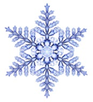
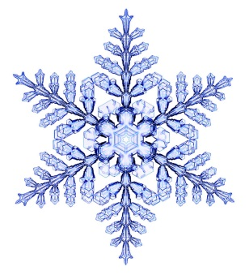

Внимание - Рождественский конкурс!!!

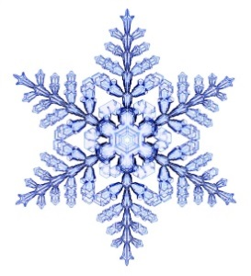
И вновь кафедра «Иностранные языки» объявляет традиционный конкурс литературных on-line переводов английской рождественской поэзии на русский язык! К участию в конкурсе приглашаются студенты, магистранты, аспиранты и все любители английской поэзии!
Сроки проведения конкурса: с 21 ноября по 15 декабря 2023г.

Для перевода предлагаются три стихотворения на выбор.

Poem 1

Christmas Hymn
Sing, Christmas bells!
Say to the earth this is the morn
Whereon our Savior-King is born;
Sing to all men,–the bond, the free,
The rich, the poor, the high, the low,
The little child that sports in glee,
The aged folk that tottering go,–
Proclaim the morn
That Christ is born,
That saveth them and saveth me!
Sing, angel host!
Sing of the star that God has placed
Above the manger in the East;
Sing of the glories of the night,
The virgin’s sweet humility,
The Babe with kingly robes bedight,–
Sing to all men where’er they be
This Christmas morn;
For Christ is born,
That saveth them and saveth me!
Poem 2

The Waits
At the break of Christmas Day,
Through the frosty starlight ringing,
Faint and sweet and far away,
Comes the sound of children, singing,
Chanting, singing,
“Cease to mourn,
For Christ is born,
Peace and joy to all men bringing!”
Careless that the chill winds blow,
Growing stronger, sweeter, clearer,
Noiseless footfalls in the snow,
Bring the happy voices nearer;
Hear them singing,
“Winter’s drear,
But Christ is here,
Mirth and gladness with Him bringing.”
“Merry Christmas!” hear them say,
As the East is growing lighter;
“May the joy of Christmas Day
Make your whole year gladder, brighter!”
Join their singing,
“To each home
Our Christ has come,
All Love’s treasures with Him bringing!”
Poem 3
Santa Claus
He comes in the night! He comes in the night!
He softly, silently comes;
While the little brown heads on the pillows so white
Are dreaming of bugles and drums.
He cuts through the snow like a ship through the foam,
While the white flakes around him whirl;
Who tells him I know not, but he finds the home
Of each good little boy and girl.
His sleigh is long, and deep, and wide;
It will carry a host of things,
While dozens of drums hang over the side,
With the sticks sticking under the strings:
And yet not the sound of a drum is heard,
Not a bugle blast is blown,
As he mounts to the chimney-top like a bird,
And drops to the hearth like a stone.
The little red stockings he silently fills,
Till the stockings will hold no more;
The bright little sleds for the great snow hills
Are quickly set down on the floor.
Then Santa Claus mounts to the roof like a bird,
And glides to his seat in the sleigh;
Not the sound of a bugle or drum is heard
As he noiselessly gallops away.

Победителями станут участники конкурса, кто сможет передать как можно ближе к оригиналу содержание английского стихотворения, сохраняя при этом поэтическую форму и соблюдая языковые и стилистические нормы русского языка. И конечно, не забывайте о рифме !

Свои работы присылайте на e-mail garibadze@rambler.ru до 15 декабря 2023г. Обязательно укажите фамилию, и.о., номер группы, факультет.

Победители конкурса будут объявлены 19 декабря, награждены грамотами, лучшие переводы будут опубликованы на сайте академии.
Творческих успехов, друзья!
